## Module – 3 Network

**Assignment 2: *This is a practical assignment. (submission is mandatory)***

**AGENDA: Enabling communication between overlapping networks which will solve Private IP exhaustion with Private NAT Solution.**

As per provided steps in assignment document, I followed the steps and executed them to check the connectivity from ‘SourceInstance-VPC-A’ to ‘WebServer-VPC-B’.

Followed and executed steps are below:

Step 1: Click on the ‘Launch Stack’ to launch cloudformation stack which will help to create the resources in ‘us-east-1’ region.

Click on ‘acknowledgement’ checkbox and click on ‘Create Stack’.

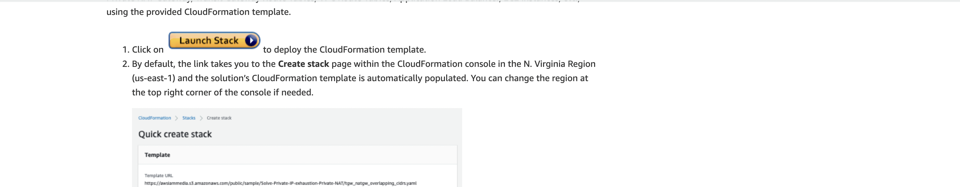

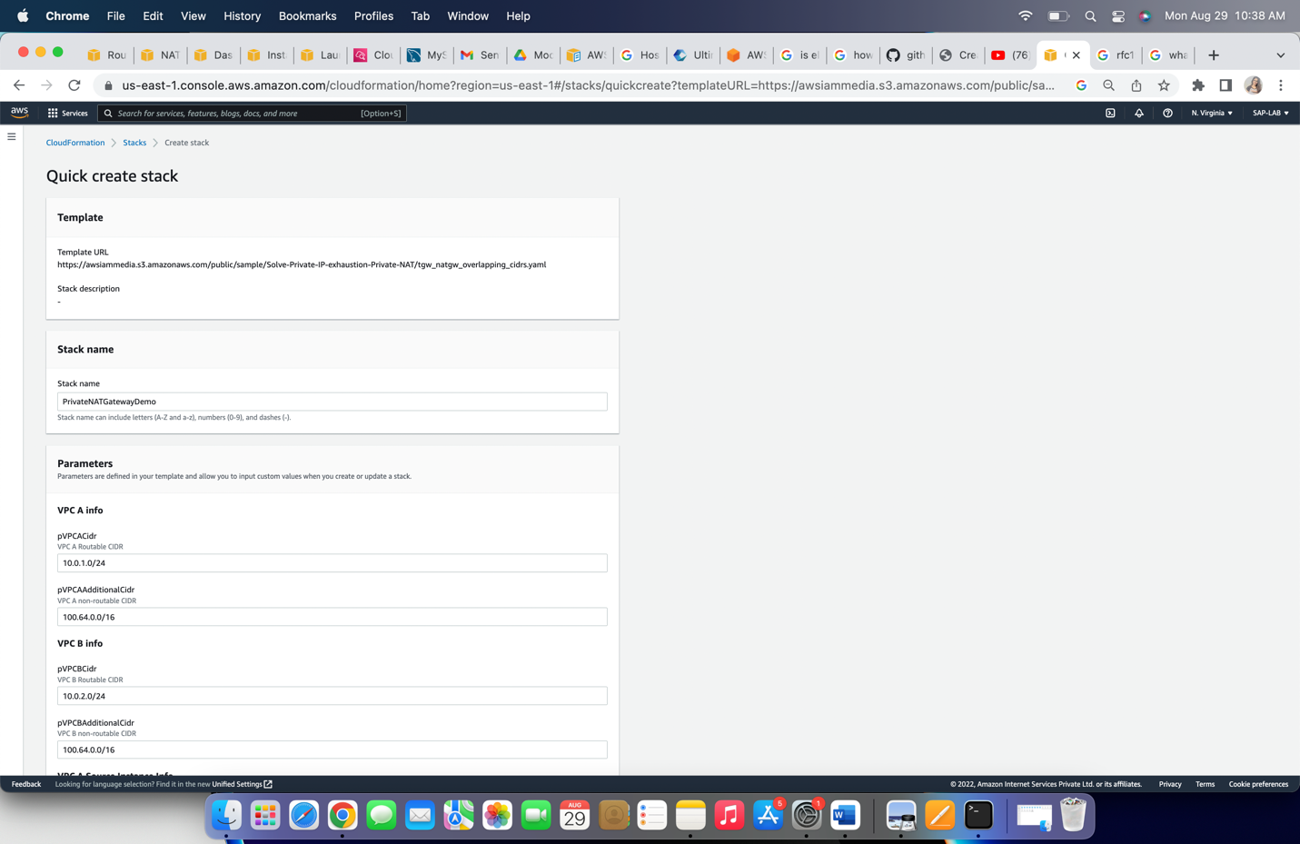

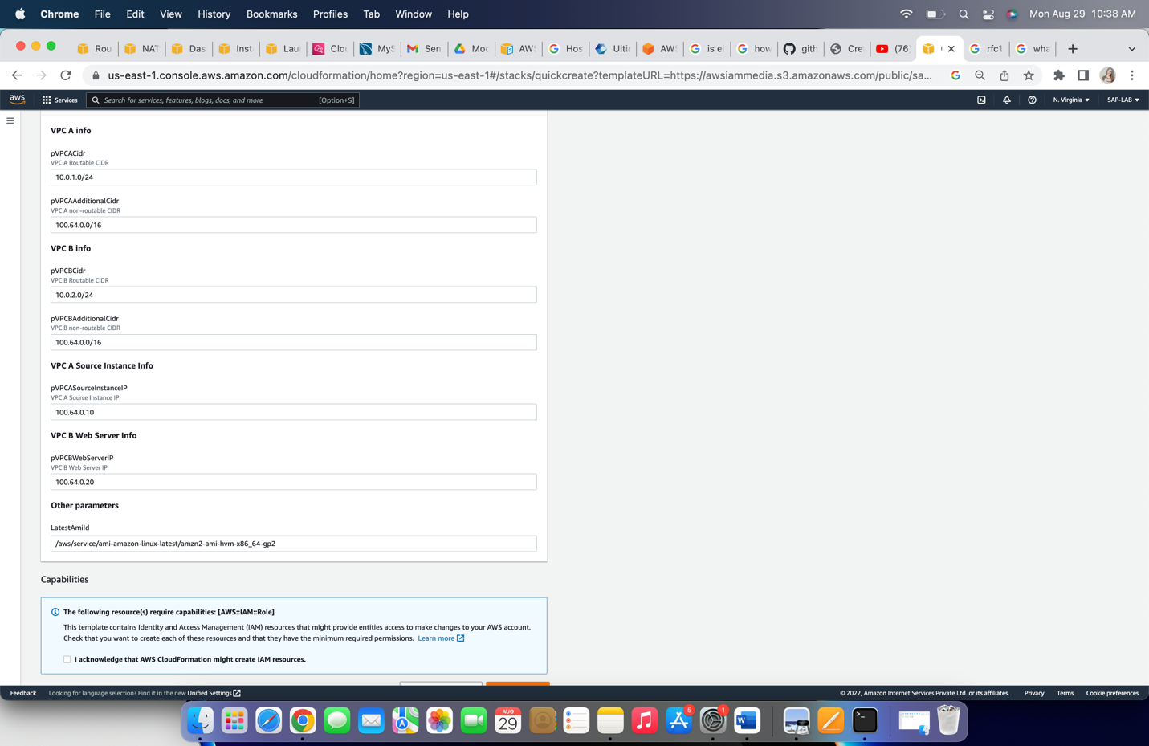

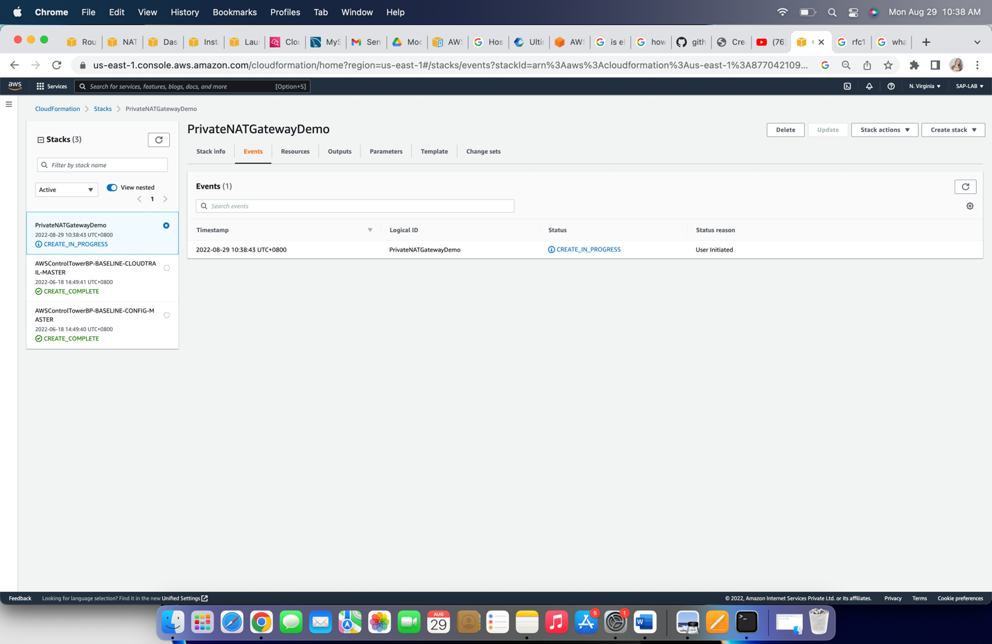

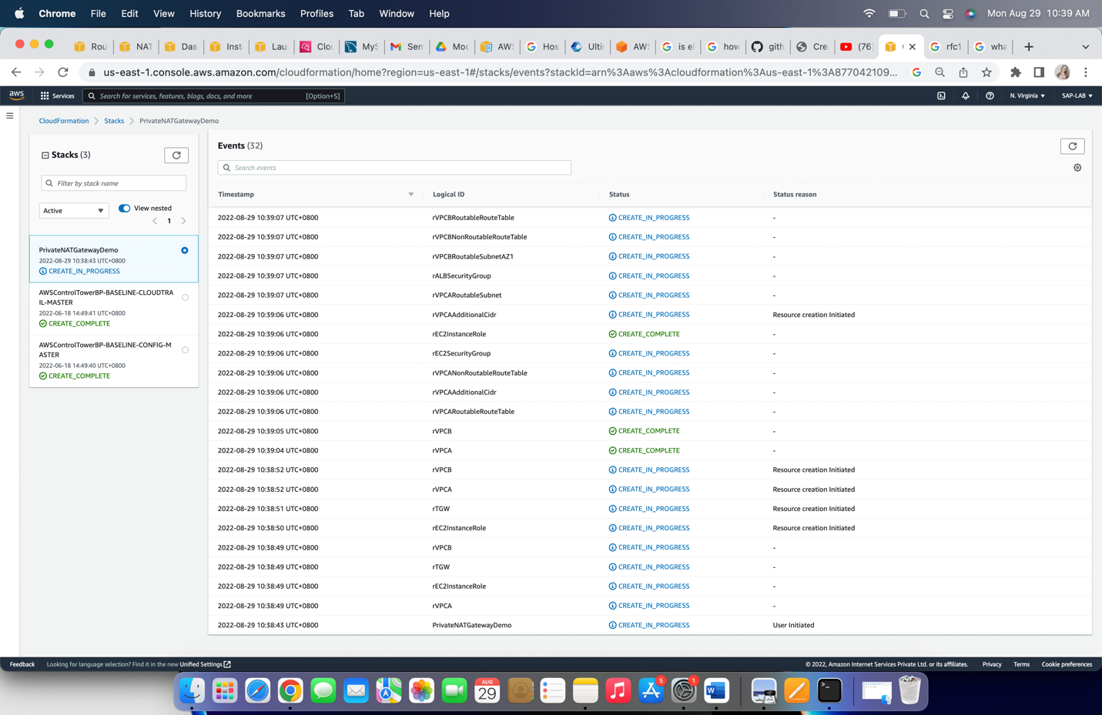

After successful creation of stack ‘PrivateNATGatewayDemo’, it will show status of stack ‘Create_complete’.

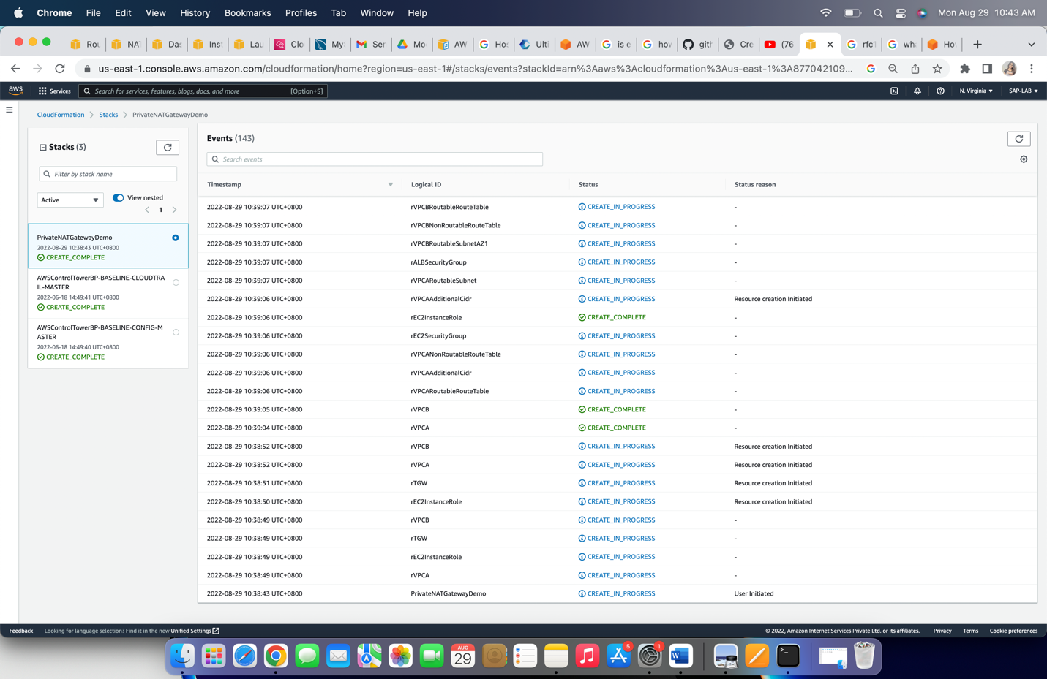

Step 2: To check the connectivity, from ‘sourceInstance’ available in VPC-A to ‘webServer’ available in VPC-B. Go to EC2 dashboard and select the ‘SouceInstance’ and click on ‘Connect’.

Choose ‘Session Manager’ from connection method and click on ‘Connect’.

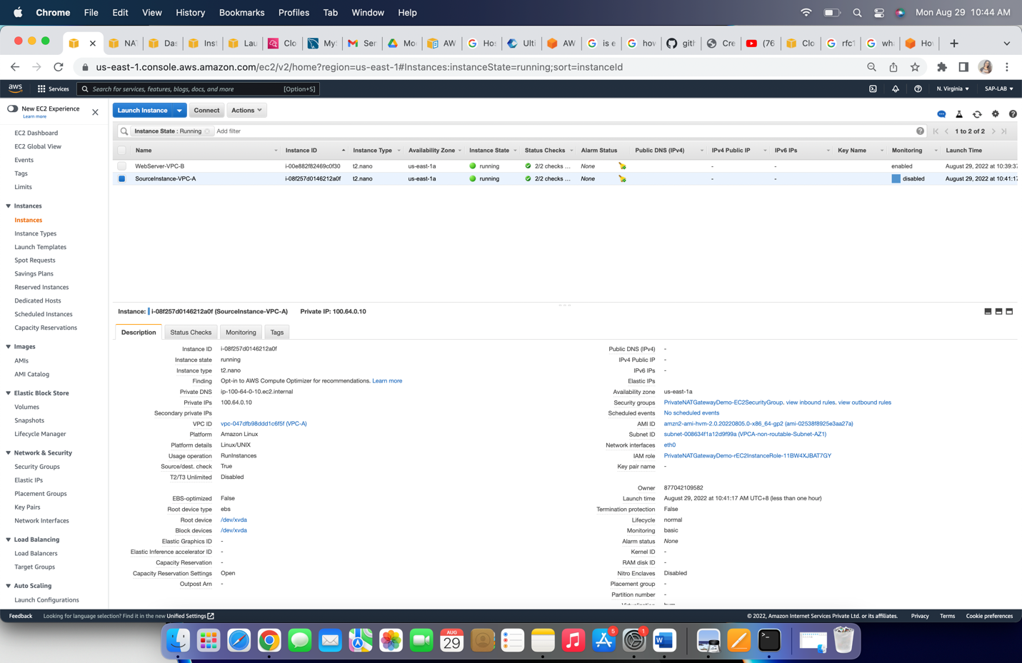

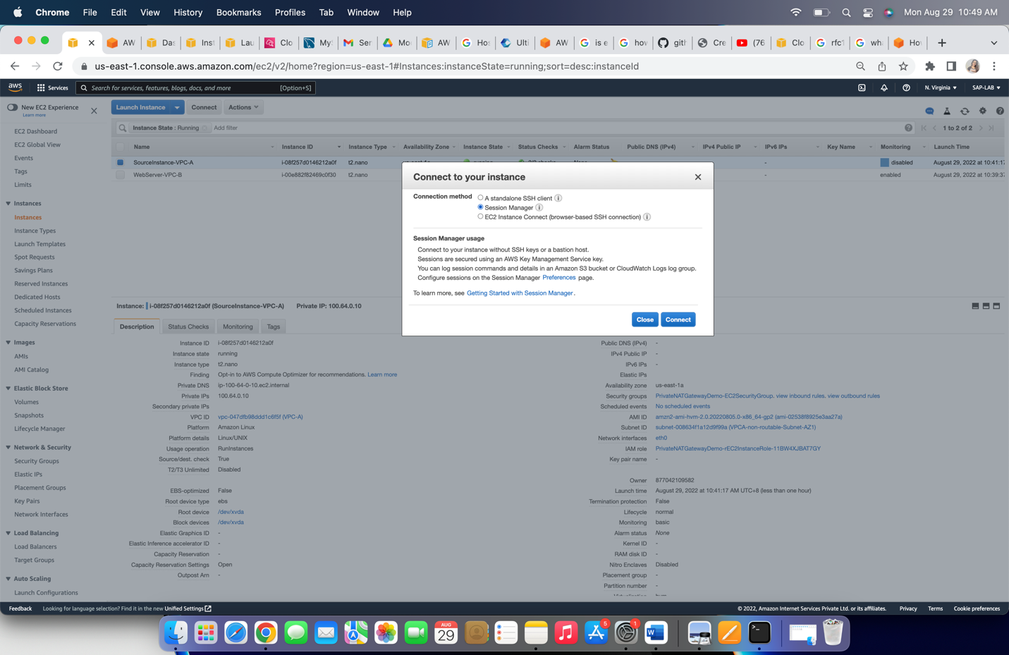

Step 3: To verify that the “SourceInstance-VPC-A” can reach the web service which is running in VPC-B(100.64.0.0/24 non-routable subnet), use curl to connect the ALB DNS name

curl <alb-dns-name>

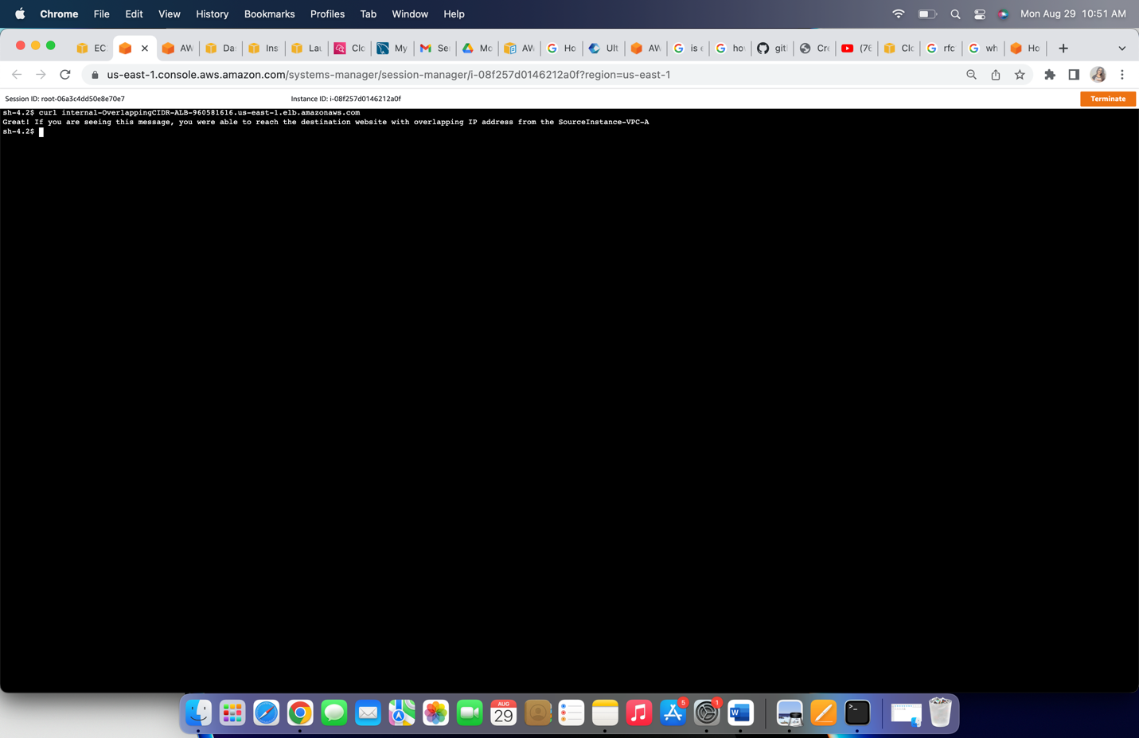

It will connect show the message as seen in above screen.

After successful connectivity terminated the session and deleted the CloudFormation stack.